

MuleSoft Installation Guide

**Document Version**

|  |  |  |  |
| --- | --- | --- | --- |
| **Date** | **Version** | **Author** | **Comments** |
| 04/20/2016 | 0.1 | A Velez, J DeRosa | Created First Draft |
|  |  |  |  |
|  |  |  |  |
|  |  |  |  |

**Table of Contents**

Introduction 3

Scope 4

Installation 5

Downloading the software 5

Installation of the Anypoint Studio 5

Install Java 5

Install Maven 6

Configure Studio for Maven Support 6

Configure Anypoint Platform Settings in Studio 7

Install AES Security (requires an Enterprise license) 7

Mule ESB Installation 9

Unpacking the installation zip file. 9

Installing the license file 9

Start your server 9

Mule Agent Installation (optional) 10

Clustering 11

Multicast setup 11

Unicast alternative 11

Appendix A – Support cases 13

Opening a MuleSoft Support Case 13

Maven - settings.xml 14

Appendix B – Amgen specifics 17

Create the directory for the installation: 17

Modify the .bash_profile file from the mule home directory, to include: 17

Heap changes 17

Hardening the installation 18

# Introduction

Amgen requested MuleSoft Professional Services to assist during the installation and configuration of MuleSoft’s environment. This installation is known as “on prem” for the purpose of this installation guide, and to differentiate it with MuleSoft’s “on cloud” installations, as significant differences in the amount of steps and concepts need to be dealt with.

This document provides a guideline of steps that took place during the installation and configuration of the platform, but it is not intended as a single source of documentation for every aspect involved (See scope for details).

# Scope

The following is a list of tasks performed as well as scope of what this document includes:

* Deploy Mule ESB in the Development environment

This document does not include:

* The installation and configuration of CI server, Jenkins, source code control

# Installation

## Downloading the software

The software is available for download following this link: https://anypoint.mulesoft.com



Under Support🡪Downloads



## Installation of the Anypoint Studio

### Install Java

Build software requires JDK 1.8 NOT a JRE (found at<http://www.oracle.com/technetwork/java/javase/downloads/index.html>)

After installing java you need to set the environment variable JAVA_HOME that points to the base directory for the java install (not the bin directory).

### Install Maven

Latest Apache maven installation zip file (apache-maven-3.3.9-bin.zip) can be downloaded from here:

<http://maven.apache.org/download.cgi>

The full installation instructions are here:

<http://maven.apache.org/install.html>

To install on Windows:

1. Unzip the distribution archive, i.e. *apache-maven-3.3.9-bin.zip* to the directory you wish to install Maven 3.3.9. These instructions assume you chose *C:\Apache*. The subdirectory apache-maven-3.3.9 will be created from the archive.
2. Add the unpacked distribution's bin directory to your user *PATH* environment variable by opening up the system properties, selecting the "Advanced" tab, and the "Environment Variables" button, then adding or selecting the *PATH* variable in the user variables with the value C:\Apache\apache-maven-3.3.9\bin.
3. In the same dialog, make sure that JAVA_HOME exists in your user variables or in the system variables and it is set to the location of your JDK, e.g. C:\Java\jdk1.8.0_74.
4. Open a *new* command prompt (Winkey + R then type cmd) and run mvn -version to verify that it is correctly installed.

# 

Download the Anypoint Studio installation zip file from the Downloads tab of your MuleSoft customer portal. You can reach your customer portal by logging in to Anypoint Platform and selecting the *Support* link.

If you currently don’t have access to your portal, you can also download Studio from here:

<https://www.mulesoft.com/platform/studio>

Note that detailed instructions are also available at that site.

1. Download the version of Studio that is compatible with your operating system: Windows, Mac, or Linux.
2. Unzip the downloaded file to a directory on a hard drive located on your host machine. The AnypointStudio folder or directory appears when the unzip operation completes.
3. Open Anypoint Studio by double-clicking the AnypointStudio.exe file, located in the AnypointStudio directory

### Configure Studio for Maven Support

From the Windows | Preferences menu, select Maven Settings and configure the appropriate values from your maven installation. Use the Test Maven Configuration button to verify your configuration settings.



### Configure Anypoint Platform Settings in Studio

During API development and testing, in order for the API application to register with Amgen’s Anypoint Platform, the client ID and secret for its organization must be configured. These values can be obtained from the Anypoint Platform site.

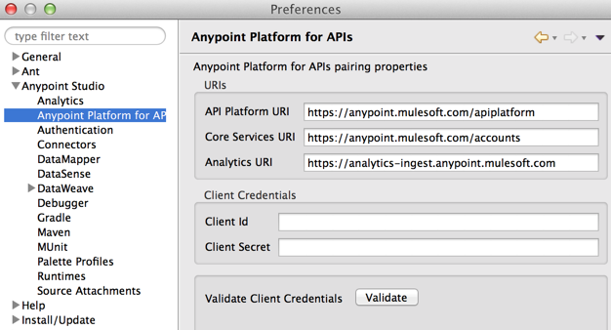

### Install AES Security (requires an Enterprise license)

Add the AES security site from the Help | Install New Software menu.

You will need to grab the update site URL for the release (e.g. 3.7.3) which you can find here: <https://docs.mulesoft.com/release-notes/anypoint-enterprise-security-release-notes>

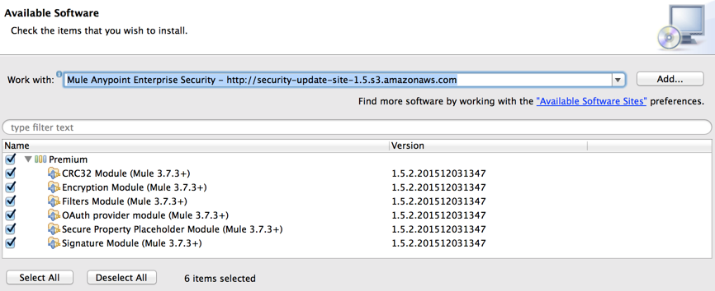

More information on Anypoint Enterprise Security can be found on the MuleSoft documentation site: <https://docs.mulesoft.com/mule-user-guide/v/3.7/anypoint-enterprise-security>

# Mule ESB Installation

## Unpacking the installation zip file.

$ tar -xzvf mule-ee-distribution-standalone-3.7.3.tar.gz

This will create a “mule-enterprise-standalone-3.7.3” directory. This becomes the MULE_HOME directory.

## Installing the license file

$ ./mule -installLicense license.lic

You should be able to see the following message, which confirms you have installed the license properly:

Installed license key.

Evaluation = false, Expiration Date = xxx, Contact Name = xxx, Contact Email Address = xxx, Contact Telephone = xxx, Contact Company = Amgen, Contact Country = US, Entitlements = xxx

## Start your server

$ ./mule start

# Mule Agent Installation (optional)

Mule 3.7.x and API Gateway 2.x provide an [older version of the Mule Agent](https://docs.mulesoft.com/mule-agent/v/1.1.1/index). This version doesn’t provide support for [Sending Data from Runtime Manager to External Monitoring Software](https://docs.mulesoft.com/cloudhub/sending-data-from-arm-to-external-monitoring-software). Version 1.4 of the Agent must be downloaded separately.

Download the Agent zip file, currently version 1.4

Unzip the file under $MULE_HOME/bin directory

Run amc_setup -U

For more information please follow [this link](https://docs.mulesoft.com/mule-user-guide/v/3.7/installing).

# Clustering

## Multicast setup

Once at least two server instances have been installed, like it is the case for UAT or Prod, Clustering is a very simple process, and it is identical for the ESB and the Gateway. Here are the steps:

1. Navigate to <https://anypoint.mulesoft.com>, then click on CloudHub
2. Navigate to the environment where you want to create a cluster, e.g. UAT
3. Register your servers by executing amc_setup on each server (see this [link](https://docs.mulesoft.com/cloudhub/managing-applications-and-servers-in-the-cloud-and-on-premises) for details)
4. Once all the servers are visible in the *Servers* tab, click on *Create Cluster*
5. Give the cluster a name, e.g. *AMGEN-UAT-ESB-CLUSTER*.
6. Choose Multicast. Multicast should be enabled on servers in the same vlan or subnet.
7. Click on the servers you want to add
8. Click on *Create Cluster*.

After servers are restarted (automatically), your configuration would have a Running status; anything different from *Running*, please check with the network team.

## Unicast alternative

Multicast is the easiest installation, however Unicast is not that difficult. The only difference with the previously described setup is the radio button for Unicast, and the selection of the IP address for the nodes that will participate in the cluster.

The following changes should be made to the wrapper.conf file under $MULE_HOME/conf:

For the ESB:

# MMC Agent settings

wrapper.java.additional.20=-Dmule.agent.enabled=true

wrapper.java.additional.21=-Dmule.mmc.bind.port=7777

This page was left intentionally blank

# Appendix A – Support cases

## Opening a MuleSoft Support Case

In order to open a MuleSoft support case, an Anypoint Platform account within the Amgen organization or sub-organization (i.e. business group) is required. An organization administrator can add a new user by inviting him/her to the Amgen Anypoint Platform organization.

Once logged in, an Organization Administrator must navigate to the settings page by selecting the gear icon near the right side of the top toolbar. From there, select on “Users” tab on the left pane within “ACCESS MANAGEMENT”. An “Invite user” button is then displayed which will pop-up a dialog to send invitations to users via email to join the organization.

The user will receive an invitation in his inbox containing a link to create an account for the relevant Amgen organization. The process is similar to any other sign-up process and is self-explanatory.

Once logged in, the user can initiate a MuleSoft support case by selecting “Support” on the top toolbar. This will redirect the user to the MuleSoft Customer Portal on Salesforce.

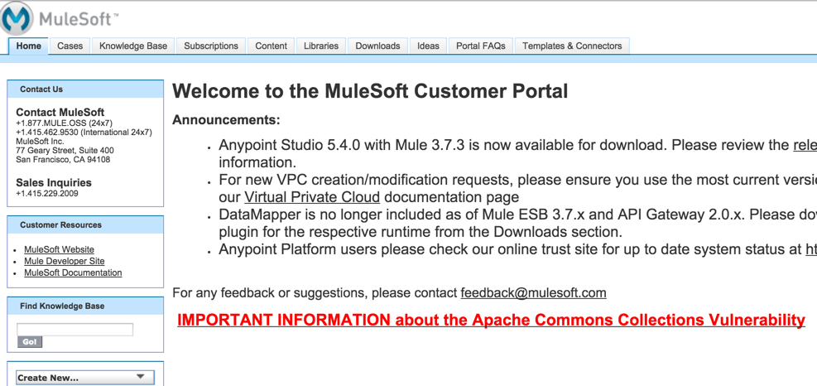

To create a case, simply select the “Cases” tab and then select “Create New Case”.

When creating a case, keep the following guidelines in mind in order to most efficiently process the support case and reduce unnecessary back-and-forth exchanges.

* The Mule support team is not as familiar with the issue being reported as you are. Provide as much detailed information as possible describing the issue in order to get the Mule support team up-to-speed on the issue.
* Include specific product information (e.g. Studio, Mule runtime, CloudHub/On-premise, version) and specific Mule components involved (e.g. connector information and version).
* If applicable, provide a sample Mule application project illustrating the issue. The most critical factor in quickly turning around a support case is for the Mule support team to be able to reproduce the issue.

## Maven - settings.xml

In order to access Mule’s enterprise repository, the enterprise repository location along with valid credentials to access it must be configured in the Maven “settings.xml” file that resides in the .m2 directory. Credentials can be acquired from MuleSoft by opening a support case requesting enterprise repository access.

Sample “settings.xml” file

|  |
| --- |
| <?xml version="1.0"?>  <settings xmlns="http://maven.apache.org/SETTINGS/1.0.0"  xmlns:xsi="http://www.w3.org/2001/XMLSchema-instance"  xsi:schemaLocation="http://maven.apache.org/SETTINGS/1.0.0 http://maven.apache.org/xsd/settings-1.0.0.xsd">  <localRepository>${user.home}/.m2/repository</localRepository>  <servers>  <server>  <id>mulesoft-ee-release</id>  <username>{Your Username}</username>  <password>{Your Password}</password>  </server>  <server>  <id>MuleRepository</id>  <username>{Your Username}</username>  <password>{Your Password}</password>  </server>  </servers>  <profiles>  <profile>  <id>default</id>  <activation>  <activeByDefault>true</activeByDefault>  </activation>  <repositories>    <repository>  <id>central</id>  <url>http://repo.maven.apache.org/maven2/</url>  <releases>  <enabled>true</enabled>  </releases>  <snapshots>  <enabled>true</enabled>  </snapshots>  </repository>    <!-- MuleSoft public repositories -->  <repository>  <id>mulesoft-releases</id>  <name>MuleSoft Repository</name>  <url>http://repository.mulesoft.org/releases/</url>  <layout>default</layout>  </repository>  <repository>  <id>mulesoft-snapshots</id>  <name>MuleSoft Snapshot Repository</name>  <url>http://repository.mulesoft.org/snapshots/</url>  <layout>default</layout>  </repository>    <!-- MuleSoft EE repositories -->  <repository>  <id>MuleRepository</id>  <name>MuleRepository</name>  <url>https://repository.mulesoft.org/nexus-ee/content/repositories/releases-ee/</url>  <layout>default</layout>  <releases>  <enabled>true</enabled>  </releases>  <snapshots>  <enabled>true</enabled>  </snapshots>  </repository>  </repositories>    <pluginRepositories>  <pluginRepository>  <id>mulesoft-release</id>  <name>mulesoft release repository</name>  <layout>default</layout>  <url>https://repository.mulesoft.org/nexus/content/repositories/public</url>  </pluginRepository>  <pluginRepository>  <id>mulesoft-ee-release</id>  <name>mulesoft release repository</name>  <layout>default</layout>  <url>https://repository.mulesoft.org/nexus/content/repositories/private</url>  </pluginRepository>  </pluginRepositories>  </profile>  </profiles>  <pluginGroups>  <pluginGroup>org.mule.tools</pluginGroup>  </pluginGroups>  </settings> |

# Appendix B – Amgen specifics

### Create the directory for the installation:

$ mkdir /opt/Mule

### Modify the .bash_profile file from the mule home directory, to include:

# .bash_profile

# Get the aliases and functions

if [ -f ~/.bashrc ]; then

. ~/.bashrc

fi

# User specific environment and startup programs

JAVA_HOME=/usr/lib/jvm/jdk1.8.0_74

PATH=$JAVA_HOME/bin:$HOME/.local/bin:$HOME/bin:$PATH

MULE_HOME=/opt/Mule/mule-enterprise-standalone-3.7.3

export JAVA_HOME

export PATH

export MULE_HOME

## Heap changes

Configure the memory of the ESB to, at a minimum, be 2Gb. Navigate to $MULE_HOME/conf and edit the wrapper.conf file. Locate the following two lines:

# Initial Java Heap Size (in MB)

wrapper.java.initmemory=1024

# Maximum Java Heap Size (in MB)

wrapper.java.maxmemory=1024

make sure that both initial and max memory are the same value. 2 Gb = 2048, so the result would look like:

# Initial Java Heap Size (in MB)

wrapper.java.initmemory=2048

# Maximum Java Heap Size (in MB)

wrapper.java.maxmemory=2048

## Hardening the installation

Please visit [this link](https://docs.mulesoft.com/mule-user-guide/v/3.7/hardening-your-mule-installation).

Should also changed the open files limit, tentatively to 8192

$ ulimit –n 8192

# sysctl -w fs.file-max=100000

# vi /etc/sysctl.conf

add this line

fs.file-max = 100000

Increase the number of max processes to a minimum of 8192